1.How are inline and block elements different from each other?
Ans.Inline elements are those which only occupy the space bounded by the tags defining the element, instead of breaking the flow of the content. It does not cause a line break and does not take up the full width of a page, only the space bounded by its opening and closing tag. It is usually used within other HTML elements.
Ex.anchor <a> tag,image <img> tag
Block elements always starts on a new line and takes up the full width of a page, from left to right. A block-level element can take up one line or multiple lines and it can have line break before and after the element.
Ex.Heading tags <h1> to <h6>,List (Ordered, Unordered, Description and List Item) tags <ol> , <ul> ,<dl> , <li>
2.Explain the difference between visibility:hidden and display:none
Hiding an element that can be done by setting the displayproperty to none. The element will be hidden, and the page will be displayed as if the element is not there in the page.
The element will be still take up the same space as before. The element will be hidden, but still affect the layout of the elements will be there in the page.

3. Explain the clear and float properties.
The float property of css tells us about how the elements should float.This property should be used for positioning and formating purpose.like left,right ,none ,inhert.
The clear property of css tells us about what elements can float beside the cleared element and on which side.like none,left,right,both,inherit.

4. explain difference between absolute, relative,fixed and static.
Static - this is the default value, all elements are in order as they appear in the document.
Relative - the element is positioned relative to its normal position.To position an element relatively, the property position is set as relative.
Absolute - the element is positioned absolutely to its first positioned parent. It has position otherthan static.
Fixed - the element is positioned related to the browser window.
5. Write the HTML code to create a table in which there are 4 columns( ID , Employee Name, Designation, Department) and at least 6 rows. Also do some styling to it.
<!DOCTYPE html>
<html>
<head>
<style>
table, th, td {
border: 1px solid black;
border-collapse: collapse;
}
</style>
</head>
<body>

<h2>HTML TABLE</h2>

<table style="width:100%">
<tr>
<th>Firstname</th>
<th>Lastname</th>
<th>Age</th>
</tr>
<tr>
<td>sonal</td>
<td>jha</td>
<td>16</td>
</tr>
<tr>
<td>suman</td>
<td>mishra</td>
<td>18</td>
</tr>
<tr>
<td>ravi</td>
<td>dubey</td>
<td>20</td>
</tr>
</table>

</body>
</html>
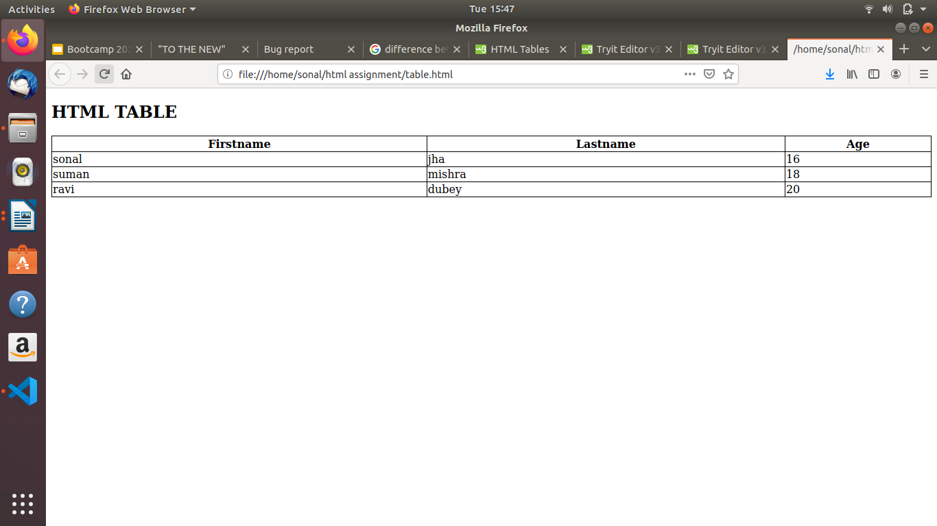

6. Why do we use meta tags?
The meta tags provides metadata about the HTML document.
Meta elements are typically used to specify page description, keywords, author of the document, last modified, and other metadata. It can also be used by browsers.
7. Explain box model.
Box model in CSS is used when we say about design and layout. It is essentially a box that is used to do wraps around every HTML element. It consists of: margins, borders, padding, and the actual content.
8. What are the different types of CSS Selectors?
- CSS Universal Selector:It is a pair of tags defines a specific webpage element. It selects all the elements on a webpage.

- CSS Element Selector:It is also known as a Type selector. In CSS IT tries to match the elements that are having the same name. Therefore, a selector of <ul> matches all the <ul> elements.i.e. ul is unorderd list.

- CSS Id Selector:It helps the developer to match the ID created by the developer to its styling content.

- CSS Class Selector:Itis one of the most helpful selectors of all the selectors. It is declared by using a dot followed by the name of the class.

- CSS Attribute Selector:It styles content according to the attribute and the attribute value mentioned in the square brackets. No spaces can be present ahead of the opening square bracket.

9. Define Doctype.
The <!DOCTYPE>declaration must be the very first thing in your HTML document, before the <html> tag.
The <!DOCTYPE> declaration is not an HTML tag. it is an instruction to the web browser about what version of HTML the page is written in.

10. Explain 5 HTML5 semantic tags.
1.Header-The <header> element is generally found at the top of a document, a section, or an article and usually contains the main heading and some navigation and search tools.
2.Footer-A <footer> is generally found at the bottom of a document, a section, or an article in which we code for submit buttons.
3.Main- It defines the main content of the document. The content inside main tag should be unique.
4.nav- It <nav>is used to define a set of navigation links in the form of navigation bar or nav menu.
5.div-It is a block level element or division of a section. It is used as a container.

11. Create HTML for web-page.jpg (check resources, highest weightage for answers)
tst.html
<!DOCTYPE html>
<html>
<head>
<meta name="description" content="detail of website">
<title> "TO THE NEW" </title>
<link rel="stylesheet" type="text/css" href="style.css"/>
</head>
<body>
<div id="div4">

<div id="div1">
<h2> TO THE NEW </h2>
<nav>
<a href='#'>TEXTLINK</a>
<a href='#'>TEXTLINK</a>
<a href='#'>TEXTLINK</a>
<a href='#'>TEXTLINK</a>
<a href='#'>TEXTLINK</a>
</nav>
</div>
<div
id="div2">
<div id="div3">
<p>960px * 360px</p>

</div>
<div id="div5">
<p>

HTML is the standard markup language for Web pages.
With HTML you can create your own Website.HTML is easy to learn - You will enjoy it!
</p>
</div>
<div id="div6">
<p>Fresh from gallery</p>
</div>
<div id="flex-container">
<div class="view">
<div class="view1">
<p>215 x 315px</p>
</div>
<p id="view-p"> Image Caption Here</p>
</div>
<div class="view">
<div class="view1">
<p>215 x 315px</p>
</div>
<p id="view-p"> Image Caption Here</p>
</div>
<div class="view">
<div class="view1">
<p>215 x 315px</p>
</div>
<p id="view-p"> Image Caption Here</p>
</div>

<div class="view">
<div class="view1">
<p>215 x 315px</p>
</div>
<p id="view-p"> Image Caption Here</p>
</div>

</div>
</div>
<footer id="footer">
<section id="footer-container">
<div> copyright &#169; 2009-2017- All Rights Reserved-to the new </div>
<div> web layout by the to the new </div>
</section>
</footer>
</div>
</body>
</html>

style.css
*{
padding: 0px;
margin: 0px;
box-sizing: border-box;
}
body{
background-color: #323232;;

}
#div4{
margin:auto;
width:1200px;

}
#div1{
margin: auto;
padding: 10px;
width: 960;
}
a{
text-decoration: none;
color: white;
}
nav{
padding:10px 10px 10px 10px;
background-color:black;

}
#div2{
background-color: white;
padding:30px 50px 30px 50px
}
#div3{
background-color:black;
height:360px;
width:960px;
padding-left: 50px;
margin:auto;
display:flex;
justify-content: center;
align-items: center;
}
p{
color: white;
margin:auto;
}
#div5{
width: 960px;
color:black;
background-color: grey;
margin:auto;
}
#div6 p{
color:grey;
font-weight: bold;
width: 960px;
margin:auto;
text-align: left;
border-bottom: 1px solid darkgrey;
}
#div7{
height:360px;
width:960px;
margin:auto;
}
/*.div8{
display: inline-block;
float:left;
background-color:black;
height:315px;
width:215px;
margin-top:30px;
margin-right:10px;
display:flex;
justify-content: center;
align-items: center;

}
.div8 p{
color:white;
}
#div9{
display:inline-block;
vertical-align: bottom;
}
.div10{
background-color: grey
width: 215px;
margin-top:30px;
}*/

#flex-container{
width:960px;
height:315px;
margin:auto;
display:flex;

}
.view{
border:1px solid grey;
width:215px;
height:296px;
color:white;
margin-right: 15px;
padding: 5px;

}
.view1{
width:215px;
height:296px;
justify-content:center;
display:flex;
background-color: #323232;

}
#view-p{
background-color: grey;
width:215px;
}
#footer-container{
width: 960px;
height:80px;
margin:auto;
display:flex;
justify-content:space-between;
color:white;
align-items:center;
}

output
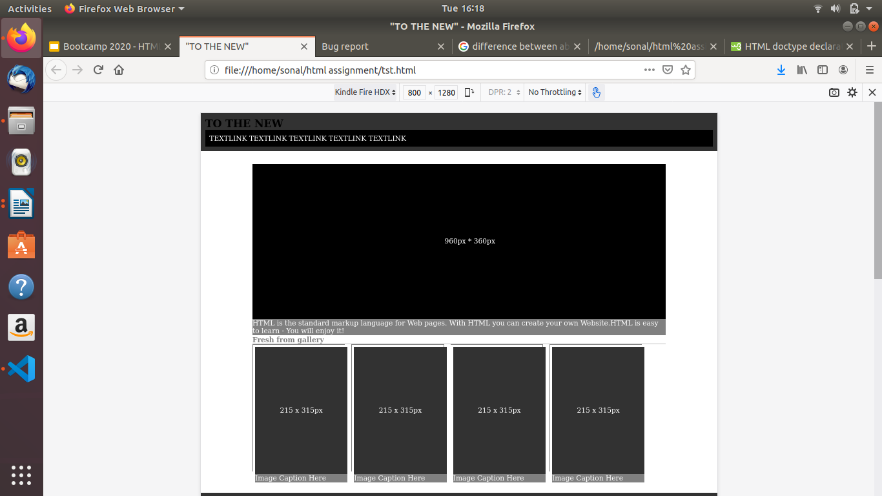

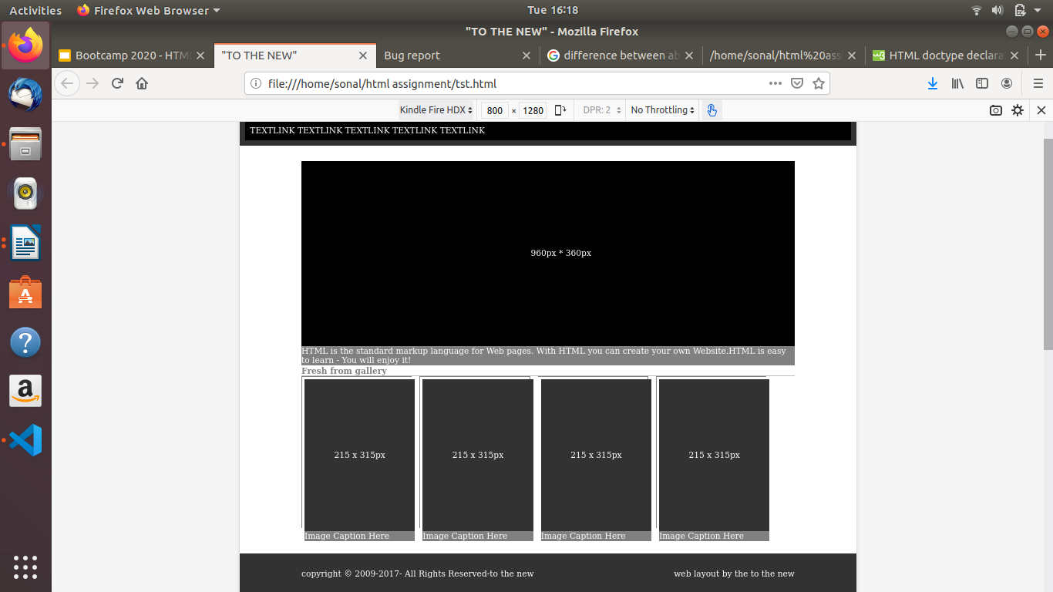
12. Create HTML for form.png (check resources, highest weightage for answers)
bug.html
<!doctype html>
<html>
<head>
<title>Bug report</title>
<link rel="stylesheet" type="text/css" href="style1.css">
</head>
<body>
<div id="div1">
<div class="header">
<span class="alignleft">TO THE NEW</span>
<span class="alignright"><a href="#">Home</a> <a href="#">Quick Help</a></span>
</div>
<br />
<hr />
<br />
<div class="bug-box">
<div id="formheader">
<h3>Bug report</h3>
</div>
<form action="#" method="post">
Title:*<br />
<input type="text" name="title" required=""><br /><br>
Description:*<br />
<textarea name="description" required=""></textarea><br /><br>
Operating system:<br />
<select name="os" style="background-color: mediumseagreen;">
<option value="xp">Windows XP</option>
<option value="7">Windows 7</option>
</select><br /><br>
Produt:*<br />
<select name="product" style="background-color: mediumseagreen;">
<option value="id">Product ID</option>
<option value="sno">Serial No</option>
</select><br /><br>
Version:*<br />
<input type="text" name="version"><br /><br>
License:<br />
<label for="free">
<input type="radio" name="license" value="free" id="free" /> Free
</label>
<input type="radio" name="license" value="business"> Business<br/><br>
Severity:<br />
<select name="Severity" style="background-color: mediumseagreen;">
<option value="critical">Critical</option>
<option value="serious">Serious</option>
</select><br /><br>
Attachment:<br />
<input type="file" name="file">
<p align="right">
<input type="submit" value="Send" style="background-color: mediumseagreen;" />
</p>

</form>

</div>
</div>
</body>
</html>

style1.css
input[type=text], select, textarea{
width:280px;
}
#formheader{
background-color: #696969;
width: 290px;
padding: 5px;
}
#div1{
border: 1px solid black;
padding: 20px;
}
.bug-box{
width:300px;
margin:0 auto;
border:2px solid black;
padding: 5px;
border-radius: 10px;
}
.alignleft{
float:left ;
font-size: 20px;
font-weight:bold ;
color: #10D5D2;
}
.alignright{
float:right;
}
.header{
padding-bottom:10px;
}
a {
text-decoration: none;
color: #10D5D2;
}

output

